**Experiment No:-01**

Use of programming tools (Debug/TASM/MASM/8086kit) to perform basic arithmetic operations on 8bit/16 bit data

**Aim:** To Use of programming tools (Debug/TASM/MASM/8086kit) to perform basic arithmetic operations on 8bit/16 bit data.

**Objective:** 1. Introduction to Microsoft Turbo Assembler (TASM)

2. General structure of an assembly language program

3. Use of the Dos Debugger program

**Software Used:**

Computer system with TASM/MASAM

**Theory:**

In general, programming of microprocessor usually takes several iterations before the right sequence of machine code instruction is written. The process, however is facilitated using a special program called an “Assembler”. The Assembler allows the user to write alphanumeric instructions. The Assembler, in turn, generates the desired machine instructions from the assembly language instructions.

Assembly language programming consists of following steps:

|  |  |  |
| --- | --- | --- |
| S.No. | STEP | PRODUCES |
| 1 | Editing | Source file |
| 2 | Assembling | Object file |
| 3 | linking | Executable file |
| 4 | Debugging | Results |

Assembling the program:

The assembler is used to convert the assembly language instructions to machine code. It is used immediately after writing the Assembly language program. The assembler starts by checking the syntax or validity of the structure of each instruction in the source file .if any errors are found, the assemblers displays a report on these errors along with brief explanation of their nature. However If the program does contain any errors , the assembler produces an object file that has the same name as the original file but with the “obj” extension

Linking the program:

The Linker is used convert the object file to an executable file. The executable file is the final set of machine code instructions that can directly be executed by the microprocessor. It is the different than the object file in the sense that it is self-contained and re-locatable. An object file may represent one segment of a long program. This segment can not operate by itself, and must be integrated with other object files representing the rest of the program ,in order to produce the final self-contained executable file

Executing the program

The executable contains the machine language code .it can be loaded in the RAM and executed by the microprocessor simply by typing, from the DOS prompt ,the name of the file followed by the carriage Return Key (Enter Key). If the program produces an output on the screen or sequence of control signals to control a piece of hard ware, the effect should be noticed almost immediately. However, if the program manipulates data in memory, nothing would seem to have happened as a result of executing the program.

Procedure to enter a program using TASM software

Start

↓

Run

↓

Type CMD

↓

Ok

Display shows

↓

C :\> D:(drive name where your folder created)

(Change to D(your) drive because TASM is in D(your) drive)

↓

Press ENTER

↓

D :\> CD TASM

↓

Press ENTER

↓

D: \TASM> EDIT FILENAME.ASM

Example edit add16.asm

↓

Press ENTER

↓

Then the display shows editor

↓

Type the asm program

↓

Then the save the program (Use Alt+F keys to appear the option window)

↓

Exit from editor Using Alt+F keys

↓

Then Display shows D: \TASM>

↓

Enter the name TASM FILENAME.ASM

Example

↓

D: \TASM> TASM add16.asm

Then Display shows Errors,(0)Warnings(0)

If there is errors correct them

↓

Enter the name Tlink FILENAME.OBJ

Example

↓

D: \TASM> TLINK add16.obj

↓

Then the display shows

Turbo Link Version 3.0

↓

Enter the name TD FILENAME.EXE

Example

↓

D: \TASM> TD add16.exe

↓

Then the display shows

Program has no symbol table

Choose OK

↓

RUN the Program using F7 key for step wise execution or F9 Key for at a time executionor Select the RUN Option

↓

See the data in Registers

↓

See the data in Data segment Using Alt+F -_View-_Dump

Procedure to enter the data into memory location.

Assembler Directives of 8086

Assembler directives give instruction to the assembler where as other instructions discussed in the above section give instruction to the 8086 microprocessor. Assembler directives are specific for a particular assembler. However all the popular assemblers like the Intel 8086 macro assembler, the turbo assembler and the IBM macro assembler use common assembler directives.

The most common assembler diretives are as follows:

ORG : Originate

ASSUME

DB : Define Byte

DD : Define Double Word

DQ : Define Quad Word

DT : Define Ten Bytes

DW : Define Word

END : Ends Program

END : End Segment

ENDP : End Procedure

EQU : Equate

INCLUDE

ORG

It is the location in memory where you want the binary program to be loaded to, if any.

ASSUME Directive

The ASSUME directive tell the assembler the name of the logical segment it should use for a specified segment. The 8086 works directly with only 4 physical segments: a Code segment, a data segment, a stack segment, and an extra segment.

Examples:

ASUME CS: CODE

This tells the assembler that the logical segment named CODE contains the instruction statements for the program and should be treated as a code segment.

ASUME DS: DATA

This tells the assembler that for any instruction which refers to a data in the data segment, data will found in the logical segment DATA.

DB

The DB directive is used to declare a byte-type variable or to set aside one or more storage locations of type byte in memory

Examples:

1. PRICE DB 49h, 98h, 29h

Declare an array of 3 bytes, named as PRICE and initialize.

2. NAME DB ‘ABCDEF’

Declare an array of 6 bytes and initialize with ASCII code for letters

3. TEMP DB 100 DUP(?)

Set 100 bytes of storage in memory and give it the name as TEMP, but leave the 100 bytes uninitialized. Program instructions will load values into these locations.

DD

The DD directive is used to declare a variable of type doubleword or to reserve memory locations which can be accessed as type doubleword

Example:

MULTIPLIER DW 437Ah

This declares a variable of type word and named it as MULTIPLIER. This variable is initialized with the value 437Ah when it is loaded into memory to run.

EXP1 DW 1234h, 3456h, 5678h

This declares an array of 3 words and initialized with specified values.

STOR1 DW 100 DUP(0)

Reserve an array of 100 words of memory and initialize all words with 0000.Array is named as STOR1

DQ

The DQ directive is used to tell the assembler to declare a variable 4 words in length or to reverse 4 words of storage in memory

END

The ENDS directive is used with the name of a segment to indicate the end of that logical segment. It is aced after the last statement of a program to tell the assembler that this is the end of the program module. The assembler will ignore any statement after an END directive. Carriage return is required after the END directive.

ENDS

This ENDS directive is used with name of the segment to indicate the end of that logic segment.

Example:

CODE SEGMENT

Hear it Start the logic; segment containing code. Some instructions to perform the logical operation.

CODE ENDS

End of segment named as CODE

ENDP

ENDP directive is used along with the name of the procedure to indicate the end of a procedure to the assembler Example:SQUARE_NUM PROCE

It start the procedure ; Some steps to find the square root of a number

SQUARE_NUM ENDP

Here it is the End for the procedure .

EQU

The EQU is used to give a name to some value or symbol. Each time the assembler finds

the name in the program, it will replace the name with the value or symbol you given to that name.

Example:

FACTOR EQU 03H

this statement is written at the starting of program and later in the program it can be used anywhere.

ADD AL, FACTOR

When assembler finds this instruction the assembler will code it as ADDAL, 03H

The advantage of using EQU in this manner is, if FACTOR is used many no of times in a program and you want to change the value, all you had to do is change the EQU statement at beginning, it will changes the rest of all.

INCLUDE

-This INCLUDE directive is used to insert a block of source code from the named file into the current source module.

DOS Function Calls

AH 00H : Terminate a Program

AH 01H : Read the Keyboard

AH 02H : Write to a Standard Output Device

AH 08H : Read a Standard Input without Echo

AH 09H : Display a Character String

AH 0AH : Buffered keyboard Input

INT 21H : Call DOS Function

To add/subtract two numbers, both the numbers need to be moved into two registers of the microprocessor (out of these two registers, one should be AX register). Then the numbers are added/subtracted using the required instruction. There is a chance of carry. So the carry needs to be saved along with the result.

MOV AX, [1200]/ MOV [1206], CX: This instruction moves the data stored in location 1200 into AX register or vice versa.

ADD AX, BX: This instruction adds the content of BX register with content of AX register and the result is stored in AX register.

SUB AX, BX: This instruction subtracts the content of BX from AX register and the result is stored in AX register.

JNC Location: This instruction makes the control jump to the “Location” if there is no carry after the arithmetic operation.

INC CX: This instruction increments the content of the CX register by 1.

HLT: This instruction stops the execution.

ALGORITHM 1: (For Addition)

Step 1: Initialize counter CX to store the carry

Step 2: Get the first data in AX register

Step 3: Get the second data in BX register

Step 4: Add the content of AX & BX registers

Step 5: Check for carry

Step 6: If carry exists, increment CX

Step 7: Store the carry

Step 8: Store the sum

Step 9: Stop the program

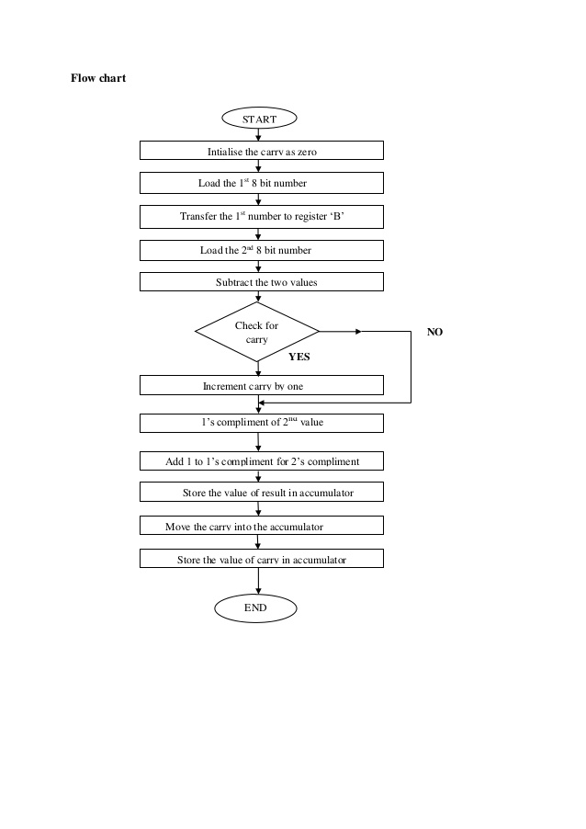

ALGORITHM 2: (For Subtraction)

Step 1: Initialize counter CX to store the borrow

Step 2: Get the first data in AX register

Step 3: Get the second data in BX register

Step 4: Subtract the content of BX from AX register

Step 5: Check for borrow

Step 6: If borrow exists, increment CX

Step 7: Store the borrow

Step 8: Store the difference

Step 9: Stop the program

**Result:**

**Conclusion:**

__________________________________________________________________________________________________________________________________________________________________________________________________________________________________________________

**Industrial Applications:** Turbo Assembler (TASM) is a computer assembler (software for program development) developed by Borland which runs on and produces code for 16- or 32-bit x86 MS-DOS or Microsoft Windows. It can be used with Borland'shigh-level language compilers, such as Turbo Pascal, Turbo Basic, Turbo Cand Turbo C++. The Turbo Assembler package is bundled with the *Turbo*[*Linker*](https://en.wikipedia.org/wiki/Linker_(computing)), and is interoperable with the Turbo Debugger. TASM can assembleMicrosoft Macro Assembler (MASM) source using its *MASM mode* and has an*ideal mode* with a few enhancements. Object-Oriented programming has been supported since version 3.0. The last version of Turbo Assembler is 5.4, with files dated 1996 and patches up to 2010; it is still supplied with Delphi andC++Builder.

TASM itself is a 16-bit program; it will run on 16- and 32-bit versions of Windows, and produce code for the same versions. There are ways to run 16-bit programs such as TASM on 64-bit Windows (e.g., on a virtual machine), but it will not generate 64-bit Windows code.

**Questions:**

1. What is a Microprocessor?

______________________________________________________________________________________________________________________________________________________________________________________________________________________________________________________

1. Differentiate between 8086 and 8088?

______________________________________________________________________________________________________________________________________________________________________________________________________________________________________________________

1. What are the functional units in 8086?

_______________________________________________________________________________________________________________________________________________________________________________________________________________________________________________________________

1. What are the flags in 8086?

_______________________________________________________________________________________________________________________________________________________________________________________________________________________________________________________________

1. Maximum clock frequency in 8086_________________.
2. List the various segment registers in 8086?

_______________________________________________________________________________________________________________________________________________________________________________________________________________________________________________________________

1. Logic calculations are done in which type of registers?

_______________________________________________________________________________________________________________________________________________________________________________________________________________________________________________________________

8. Assembly Language requires less memory and execution time.(True/False)

Ans:____________________________________________________________________________

9. Each personal computer has a _________ that manages the computer’s arithmetical, logical and control activities.  
a) Microprocessor b) Assembler c) Microcontroller d) Interpreter

Ans:____________________________________________

10. List the common Assembler Directives of 8086

____________________________________________________________________________________________________________________________________________________________________

**Experiment No:-02**

Assembly programming for 16-bit addition, subtraction, multiplication and division (menu based)

**Aim:** To develop programs for addition , subtraction ,multiplication & for division using 8086 microprocessor.

**Objective:** At the start of the subject, students need to understand the basic instructions of 8086 microprocessor. This is the program which uses the basic instructions for finding addition/subtraction or multiplication/division of two 16 bit numbers (along with the higher order product).

**Software Used:**

Computer system with TASM/MASAM

**Theory:** To add/subtract two numbers, both the numbers need to be moved into two registers of the microprocessor (out of these two registers, one should be AX register). Then the numbers are added/subtracted using the required instruction. There is a chance of carry. So the carry needs to be saved along with the result.

MOV AX, [1200]/ MOV [1206], CX: This instruction moves the data stored in location 1200 into AX register or vice versa.

ADD AX, BX: This instruction adds the content of BX register with content of AX register and the result is stored in AX register.

SUB AX, BX: This instruction subtracts the content of BX from AX register and the result is stored in AX register.

JNC Location: This instruction makes the control jump to the “Location” if there is no carry after the arithmetic operation.

INC CX: This instruction increments the content of the CX register by 1.

HLT: This instruction stops the execution.

**ALGORITHM 1:** (For Addition)

**Step 1:** Initialize counter CX to store the carry

**Step 2:** Get the first data in AX register

**Step 3:** Get the second data in BX register

**Step 4:** Add the content of AX & BX registers

**Step 5:** Check for carry

**Step 6:** If carry exists, increment CX

**Step 7:** Store the carry

**Step 8:** Store the sum

**Step 9:** Stop the program

**ALGORITHM 2:** (For Subtraction)

**Step 1:** Initialize counter CX to store the borrow

**Step 2:** Get the first data in AX register

**Step 3:** Get the second data in BX register

**Step 4:** Subtract the content of BX from AX register

**Step 5:** Check for borrow

**Step 6:** If borrow exists, increment CX

**Step 7:** Store the borrow

**Step 8:** Store the difference

**Step 9:** Stop the program

To multiply/divide two numbers, both the numbers need to be moved into two registers of the microprocessor (out of these two registers, one should be AX register). Then the numbers are multiplied/divided using the required instruction. There is a chance of carry. So the carry needs to be saved along with the result.

MOV AX, [1200]/ MOV [1206], CX : This instruction moves the data stored in location 1200 into AX register or vice versa.

MUL BX: This instruction multiplies the content of BX register with content of AX register and the result is stored in AX register. The higher order of the product is stored in DX register.

DIV BX: This instruction divides the content of AX by the content of BX register, the result is stored in AX register. The higher order of the product is stored in DX register.

HLT: This instruction stops the execution.

**ALGORITHM 1:** (For Multiplication)

**Step 1:** Get the first data in AX register

**Step 2:** Get the second data in BX register

**Step 3:** Multiply the content of AX & BX registers

**Step 4:** Store the lower order product (AX)

**Step 5:** Store the higher order product (DX)

**Step 6:** Stop the program

**ALGORITHM 2:** (For Division)

**Step 1:** Get the first data in AX register

**Step 2:** Get the second data in BX register

**Step 3:** Divide the content of AX by BX register

**Step 4:** Store the lower order product (AX)

**Step 5:** Store the lower order product (DX)

**Step 6:** Stop the program

**Industrial Application:** Assembly level programming is very important to low-level embedded system design is used to access the processor instructions to manipulate hardware.  It is a most primitive machine level language is used to make efficient code that consumes less number of clock cycles and takes less memory as compared to the high-level programming language. It is a complete hardware oriented programming language to write a program the programmer must be aware of embedded hardware. Here, we are providing basics of assembly level programming 8086.

**Result:**

**Conclusion:** ____________________________________________________________________________________________________________________________________________________________________________________________________________________________________________________________

**Questions:**

1. How 8086 is faster than 8085?

________________________________________________________________________________________________________________________________________________________________________________________________________________________________________________________________________________________________________________________________________________

1. What does EU do?

________________________________________________________________________________________________________________________________________________________________________________________________________________________________________________________________________________________________________________________________________________

1. Which Segment is used to store interrupt and subroutine return address registers?

________________________________________________________________________________________________________________________________________________________________________________________________________________________________________________________________________________________________________________________________________________

1. What does microprocessor speed depend on?

____________________________________________________________________________________________________________________________________________________________________________________________________________________________________________________________

1. What is the size of data bus and address bus in 8086?

____________________________________________________________________________________________________________________________________________________________________________________________________________________________________________________________

1. The maximum memory addressing capability of 8086 is ___________________ .
2. What is flag?

____________________________________________________________________________________________________________________________________________________________________________________________________________________________________________________________

1. INC CX instruction increments the content of the CX register by 1.(True/False)

____________________________________________________________________________________

1. Which instruction is used to stop the execution ?

________________________________________________________________________________________________________________________________________________________________________

10.List out instruction to perform addition ,subtraction ,multiplication and division.

________________________________________________________________________________________________________________________________________________________________________

**Experiment No: 03**

Assembly program to find minimum/maximum no. from a given array.

**Aim:** To develop a program to find the smallest from a set of N numbers using Intel 8086 microprocessor.

**Objective:** The students need to use various instructions of 8086 microprocessor to build different programs of their own. This is the program which needs the use of complex instructions and many control moves for finding the smallest from N 16 bit numbers.

**Software Used:**

Computer system with TASM/MASAM

**Theory:** To find the smallest of N numbers, all the numbers are stored starting from a location. Then first two numbers need to be moved into two register of the microprocessor (one should be accumulator). Then both the numbers are compared and the smaller one is preserved in accumulator while larger one is discarded. This step continues for all the next numbers. A counter needs to be maintained for counting the number of numbers checked till now. The process stops after all the numbers have been checked & the smallest number is saved in memory.

MOV AX, [1200]/ MOV [1206],CX : This instruction moves the data stored in location 1200 into AX register or vice versa.

CMP CX, DX: This instruction compares the content of CX with DX register and the result is stored in AX register.

JNZ Location: This instruction makes the control jump to the “Location” if the result is not zero after the arithmetic operation.

INC CX: These instruction increments the content of the CX register by 1.

DEC CL: This instruction decrements the content of the CX register by 1.

JB Location: If the result is below 1, this instruction jumps the control to “Location”

HLT: This instruction stops the execution.

**ALGORITHM :**

**Step 1:** Initialize the starting location of the array in SI register

**Step 2:** Store the count in CL register

**Step 3:** Store the first number ([SI]) in AL register

**Step 4:** Decrement the count

**Step 5:** Move the SI pointer to next data ( INC SI)

**Step 6:** Compare AL & SI

**Step 7:** If AL < [SI] then go to step 4

**Step 8:** Else store [SI] in AL and go to step 4

**Step 9:** Store the result(AL) in a memory location

**Step 10:** Stop the program

**Flowchart:**

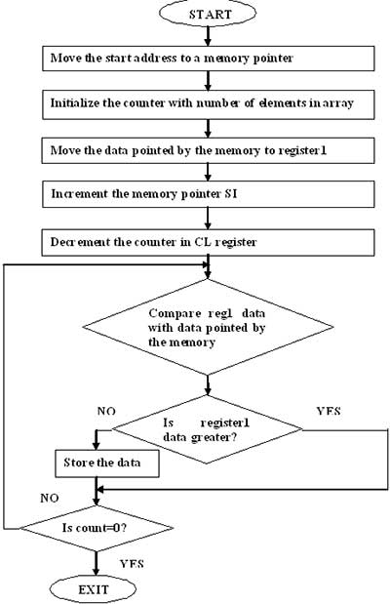

**Industrial Applications:** To find minimum/ maximum no. from the data or information in the Industry.

**Result:**

**Conclusion:** ________________________________________________________________________________________________________________________________________________________________________________________________________________________________________________________________________________________________________________________________________________

**Questions:**

1. Give examples for Maskable interrupts?

________________________________________________________________________________________________________________________________________________________________________________________________________________________________________________

1. How do you find the largest element in an array?

__________________________________________________________________________________ ______________________________________________________________________________________________________________________________________________________________________________________________________________________________________________________

1. What is the difference between Macro and Procedure?

________________________________________________________________________________________________________________________________________________________________________________________________________________________________________________________________________________________________________________________________

1. How do you find the smallest element in an array?

________________________________________________________________________________________________________________________________________________________________________________________________________________________________________________________________________________________________________________________________

1. The last statement of the source program should be _______

[A.](javascript:%20void(0)) Stop [B.](javascript:%20void(0)) Return [C.](javascript:%20void(0)) OP [D.](javascript:%20void(0)) End

ANS: ______________________________________________________________

1. Which instruction is used to decrement the content of register?

________________________________________________________________________________________________________________________________________________________________________________________________________________________________________________________________________________________________________________________________________

1. The JB instruction used for___________________________________________________
2. CMP instruction compares the content register and the result is stored in AX register.(True/False)

ANS:________________________________

1. Which instruction is used to increment the content of register? ____________________________________________________________________________________________________________________________________________________________________________________________________________________________________________________________________________________________________________________________
2. What is the disadvantage of microprocessor?

________________________________________________________________________________________________________________________________________________________________________________________________________________________________________________________________________________________________________________________________________

**Experiment No: 04**

Code conversion Hex to BCD

**Aim:** To develop a program to Code conversion Hex to BCD

**Objective:** The students need to use various instructions of 8086 microprocessor to build different programs of their own. This is the program which convert Hex numbers to its BCD equivalent.

**Software Used:**

Computer system with TASM/MASAM

**Theory:** To convert from HEX to BCD, you have to first convert the HEX to Decimal, then convert the Decimal digits to BCD digits, by converting each Decimal digit to 4 binary digits.A 4 digit  Hex  number  whose equivalent binary number is to be found i.e. FFFF H. Initially we compare FFFF H with decimal 10000 ( 2710 H in Hex ). If number is greater than 10,000 we add it to DH register. Also, we subtract decimal 10,000 from FFFF H, each time comparison is made. Then we compare the number obtained in AX by 1000 decimal. Each time we subtract 1000 decimal from AX and add 1000 decimal to BX. Then we compare number obtained in AX by 100 decimals. Each time we subtract 100 decimal from AX and add 100 decimal to BX to obtain BCD equivalent. Then we compare number obtained in AX with 10 decimal. Each time we subtract 10 decimal from AX and we add 10 decimal to BX. Finally we add the result in BX with remainder in AX. The final result is present in register DH with contains the 5th bit if present and register AX.

## Algorithm :

**Step I              :**Initialize the data segment.

**Step II             :**Initialize BX = 0000 H and DH = 00H.

**Step III           :** Load the number in AX.

**Step IV           :**Compare number with 10000 decimal. If below goto step VII else goto step V.

**Step V             :**Subtract 10,000 decimal from AX and add 1 decimal to DH

**Step VI           :**Jump to step IV.

**Step VII          :**Compare number in AX with 1000, if below goto step X else goto step VIII.

**Step VIII        :**Subtract 1000 decimal from AX and add 1000 decimal to BX.

**Step IX           :**Jump to step VII.

**Step X             :**Compare the number in AX with 100 decimal if below goto step XIII

**Step XI           :**Subtract 100 decimal from AX and add 100 decimal to BX.

**Step XII         :**Jump to step X

**Step XIII        :**Compare number in AX with 10. If below goto step XVI

**Step XIV        :**Subtract 10 decimal from AX and add 10 decimal to BX..

**Step XV          :**Jump to step XIII.

**Step XVI        :**Add remainder in AX with result in BX.

**Step XVII      :**Display the result in DH and BX.

**Step XVIII     :**Stop.

**Fl owchart:**

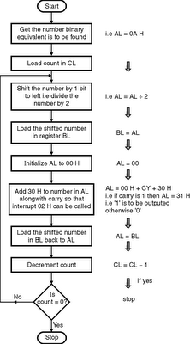

**Industrial Applications:** Microcontroller firmware usually deals with hexadecimal **code**. ... requires a hexadecimal-to-BCD (binary-coded-decimal)-**code**conversion.

**Result:**

**Conclusion:** ________________________________________________________________________________________________________________________________________________________________________________________________________________________________________________________________________________________________________________________________________________

**Questions:**

1. How to convert hexadecimal number to BCD number

____________________________________________________________________________________________________________________________________________________________________________________________________________________________________________________________________________________________________________________

1. A code converter is a logic circuit that _____________  
   a) Inverts the given input b) Converts into decimal number  
   c) Converts data of one type into another type d) Converts to octal

Ans:_____________________________________________________________________________

1. The binary representation of BCD number 00101001 (decimal 29) is ___________  
   a) 0011101 b) 0110101 c) 1101001 d) 0101011

Ans:_____________________________________________________________________________

1. ABC is a valid hexadecimal number.( True/ False)

Ans:_____________________________________________________________________________

1. List step involved in Hex to BCD conversion.

____________________________________________________________________________________________________________________________________________________________________________________________________________________________________________________________________________________________________________________

1. The symbol D represent in a hexadecimal number system is_________
2. 2. BCD uses 6 bits to represent a symbol. ( True/ False)

Ans:________________________________________________________________________________

1. State the application of Hex to BCD conversion.

____________________________________________________________________________________________________________________________________________________________________________________________________________________________________________________________________________________________________________________

1. What are the benefits of BCD code?

____________________________________________________________________________________________________________________________________________________________________________________________________________________________________________________________________________________________________________________

1. What are the disadvantages of BCD code.

____________________________________________________________________________________________________________________________________________________________________________________________________________________________________________________________________________________________________________________

**Experiment No. 5**

Assembly program to find factorial of number using procedure

**Aim:** To develop a program to find the factorial of a number using Intel 8086 microprocessor.

**Objective:** The students need to use various instructions of 8086 microprocessor to build different programs of their own. This is the program which needs the use of few instructions and a loop for finding the factorial of a number.

**Software Used:**

Computer system with TASM/MASAM

**Theory:** Procedures or subroutines are very important in assembly language, as the assembly language programs tend to be large in size. Procedures are identified by a name. Following this name, the body of the procedure is described which performs a well-defined job. End of the procedure is indicated by a return statement.

## Syntax

Following is the syntax to define a procedure −

proc_name:

procedure body

...

ret

The procedure is called from another function by using the CALL instruction. The CALL instruction should have the name of the called procedure as an argument as shown below −

CALL proc_name

The called procedure returns the control to the calling procedure by using the RET instruction

To find the factorial of a number, the number needs to be moved into a register of the microprocessor. Then accumulator is initialized with 1. Then the number is multiplied with accumulator and the number is decreased by 1. This step continues till the number is decreased to 1. The process stops after this and the result is stored.

MOV AX, [1200]/ MOV [1206],CX : This instruction moves the data stored in location 1200 into AX register or vice versa.

MUL CX: This instruction multiplies the content of CX register with content of AX register and the result is stored in AX register.

DEC DX: This instruction decrements the content of DX register by 1.

CMP CX, DX: This instruction compares the content of CX with DX register and the result is stored in AX register.

JNZ Location: This instruction makes the control jump to the “Location” if the result is not zero after the arithmetic operation.

HLT: This instruction stops the execution.

**ALGORITHM :**

**Step 1:** Initialize the CX to store the number

**Step 2:** Initialize the DX to store the number

**Step 3:** Initialize the AX to 1

**Step 4:** Multiply CX with AX register

**Step 5:** Decrease the content of DX register by 1

**Step 6:** Compare CX & DX

**Step 7:** If not zero then go to step 4

**Step 8:** Store the result (AX) in a memory location

**Step 9:** Stop the program

**Flowchart:**

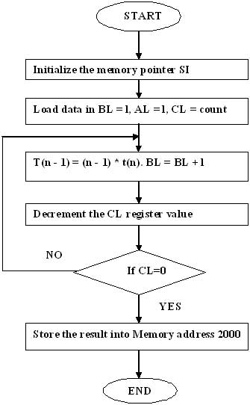

**Industrial Application :** There are many practical situations in which recursion can be a valuable technique—among them is the classic programming problem called Bill of Materials. This problem has at least two different applications, which include:

* Given the demand for one instance of an object, produce the Bill of Materials required to build it.
* Given specific inventory levels of the constituent objects that comprise an object, how many objects of this kind can we build?

**Result:**

**Conclusion:**

**________________________________________________________________________________________________________________________________________________________________________________________________________________________________________________________________________________________________________________________________________________**

**Questions:**

1. Differenciate between Macro and Procedure?

_________________________________________________________________________________________________________________________________________________________________________________________________________________________________________________________________________________________________________________________________________________________________________________________________________________________

1. What is procedure ?

____________________________________________________________________________________________________________________________________________________________________________________________________________________________________________________________________________________________________________________________________________

* 1. List the application of procedure?

____________________________________________________________________________________________________________________________________________________________________________________________________________________________________________________________________________________________________________________________________________

1. What is advantages of procedure?

________________________________________________________________________________________________________________________________________________________________________________________________________________________________________________________________________________________________________________________________________________

1. The syntax to define a procedure is___________________________________________________
2. Which of the following methods can be used to find the factorial of a number?  
   a)Recursion b)Iteration c)Dynamic programming d) All of the mentioned?

Ans:________________________________________________________________________________

1. Give example for finding factorial ***?***

____________________________________________________________________________________________________________________________________________________________________________________________________________________________________________________________

1. The instruction that unconditionally transfers the control of execution to the specified address is  
   a)CALL b)JMP c)RET d) IRET

Ans:________________________________________________________________________________

9.JNZ Location instruction makes the control jump to the “Location” if the result is not zero after the arithmetic operation.(True/False)

Ans:________________________________________________________________________________

10.INC destination increments the content of destination by __________________________________

A. 1 B. 2 C. 30 D. 41

Ans:________________________________________________________________________________

**Experiment No.06**

Assembly program to display the contents of the flag register.

**Aim:** Write an Assembly Language Program to display the contents of a flag register.

**Objective:** Write an assembly language program to display the contents of 16 bit flag register.

**Software Used:**

Computer system with TASM/MASAM

**Theory:-**

* Flag register is a part of EU (Execution Unit). It is a 16 bit register with each bit corresponding to a flip-flop. A flag is a flip-flop. It indicates some condition produced by the execution of an instruction. For example the zero flag (ZF) will set if the result of execution of an instruction is zero. Figure below shows the details of the 16 bit flag register of 8086 CPU.

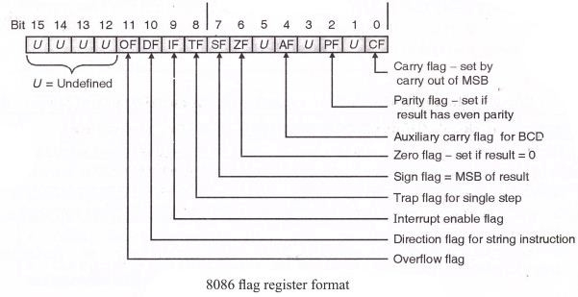

* It consists of 9 active flags out of 16. The remaining 7 flags marked ‘U’ are undefined flags.
* These 9 flags are of two types: 6 status flages and 3 control flages

**Status flags:**

**1. Carry flag (CY)****:**It is set whenever there is a carry or borrow out of the MSB (most significant bit) of a result. D7 bit for an 8 bit operation and D15 bit for a 16 bit operation.

1. **Parity flag (PF)-**It is set if the result has even parity. If parity is odd, PF is reset. This flag is normally used for data transmission errors.

**3. Auxiliary carry flag (AC)-**It is set if a carry is generated out of the lower nibble. It is used only in 8 bit operations like DAA and DAS.

**4. Zero flag (ZF)-**It is set if the result is zero.

|  |  |
| --- | --- |
| **5.** | **Sign flag (SF)-** |
|  | It is set if the MSB of the result is 1. For signed operations such a number is treated as negative. |
| **6.** | **Overflow flag (OF)-** |

It will be set if the result of a signed operation is too large to fit in the number of bits available to

represent it. It can be checked using the instruction INTO (Interrupt on Overflow).

**Control flags:**

**1. Trap flag (TF)-**It is used to set the trace mode i.e. start single stepping mode.Here the microprocessor is interrupted after every instruction so that the program can be de-bugged.

1. **Interrupt enable flag (IF)-**It is used to mask (disable) or unmask (enable) the INTR interrupt. If user sets IF flag, the CPU will recognize external interrupt requests. Clearing IF disables these interrupts.
2. **Direction flag (DF)-**If this flag is set, SI and DI are in auto-decrementing mode in string operations.

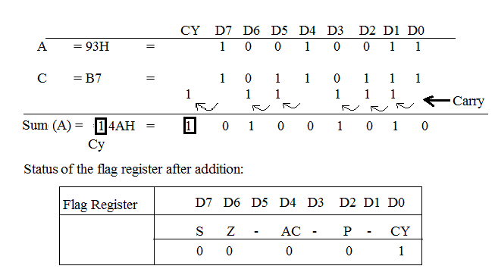

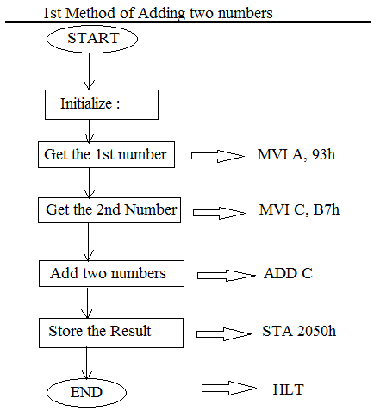

**Industrial Applications:** Display the contents of the flag register is used in microprocessor is a semiconductor device (Integrated Circuit) manufactured by the VLSI (Very Large Scale Integration) technique.

**Result:**

**Conclusion:­________________________________________________________________________________________________________________________________________________________________________**

**____________________________________________________________________________________**

**Questions**:

**1.** The 16 bit flag of 8086 microprocessor is responsible to indicate

A. the condition of result of ALU operation B. the condition of memory

C. the result of addition D. the result of subtraction

Ans:_____________________________________________________________________________

**2.** The register AX is formed by grouping

A. AH & AL B. BH & BL C. CH & CL D. DH & DL

Ans:_____________________________________________________________________________

**3.What is the function of flag register?**

**________________________________________________________________________________________________________________________________________________________________________________________________________________________________________________________________________________________________________________________________________________**

**4.The** Trap flag (TF**)** is used to set the trace mode.(True/False)

Ans:________________________________________________________________________________

**5.** The IF is called as_________________________________________________.

**6. List the different status flag in 8086.**

**____________________________________________________________________________________________________________________________________________________________________________________________________________________________________________________________**

**7. Which are the different control flag in 8086?**

**____________________________________________________________________________________________________________________________________________________________________________________________________________________________________________________________**

**8.The size of flag register in 8086 is __________________________________________________________**

**9.List the application of flag register.**

**________________________________________________________________________________________________________________________________________________________________________________________________________________________________________________________________________________________________________________________________________________**

10. Which flag is normally used for data transmission errors?

________________________________________________________________________________________________________________________________________________________________________

**Experiment No. 07**

Assembly program to find the GCD/ LCM of two numbers

**Aim:** Write an Assembly Language Program to find GCD/LCM of two numbers.

**Objective:** Write a mixed language code to calculate GCD of 2 numbers.

**Software Used:**

Computer system with TASM/MASAM

**Theory:-** Load two registers with two Numbers  and then apply the logic for GCD of two Numbers . GCD of two numbers is performed by dividing the greater number by the smaller number till the remainder is zero. If it is zero, the divisor is the GCD if not the remainder and the divisor of the previous division are the new set of two numbers. The process is repeated by dividing greater of the two numbers by the smaller number till the remainder is zero and GCD is found.

**Algorithm:**

Step I            : Initialize the data segment.

Step II          : Load AX and BX registers with the operands.

Step III        : Check if the two numbers are equal. If yes goto step X, else goto step IV.

Step IV         : Is number 1 > number 2 ? If yes goto step VI else goto step V.

Step V          : Exchange the contents of AX and BX register, such that AX contains the bigger number.

Step VI         : Initialize DX register with 00H.

Step VII       : Perform the division operation (contents of AX / contents of BX).

Step VIII     : Check if there is remainder. If yes goto step IX, else goto step X.

Step IX        : Move the remainder into AX register and goto step IV.

Step X          : Save the contents of BX as GCD.

Step XI        : Display the result.

Step XII       : Stop.

**Flowchart:**

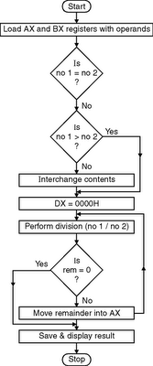

**Result:**.

**Conclusion:-**

**Industry Application:** To find smallest positive integer which is divisible by both numbers. The GCD is used for a variety of applications in number theory, particularly in modular arithmetic and thus encryption algorithms such as RSA. The application of LCM (Lowest Common Multiple) in solving CAT Quantitative Aptitude Problems.

**Questions:**

**1.Which microprocessor accepts the program written for 8086 without any changes?**

**___________________________________________________________________________________________________________________________________________________________________________________________________________________________________________________________**

**2. How to find LCM?**

**____________________________________________________________________________________________________________________________________________________________________________________________________________________________________________________________**

**3. Write in short the assembly code for to find LCM.**

**________________________________________________________________________________________________________________________________________________________________________________________________________________________________________________________________________________________________________________________________________________**

**4 .Write in short the assembly code for to find GCD?**

**________________________________________________________________________________________________________________________________________________________________________________________________________________________________________________________________________________________________________________________________________________**

**5. The GCD stand for__________________________________________________________________**

**6.** Which of the following is also known as GCD?  
a) Highest Common Divisor b) Highest Common Multiple  
c) Highest Common Measure d) Lowest Common Multiple

Ans:_______________________________________________________________________________

**7.** The gcd an associative function.( True/ False)

Ans:_______________________________________________________________________________

8.Which is the correct term of the given relation, gcd (a, b) * lcm (a, b) =?  
a) |a*b| b) a + b c) a – b d) a / b

9. The LCM stand for _____________________________________________________.

# 10. How is the concept of the least common multiple useful in real life ?

**________________________________________________________________________________________________________________________________________________________________________________________________________________________________________________________________________________________________________________________________________________**

**Experiment No. 08**

Assembly program to sort numbers in ascending/ descending order

**Aim:** Write an Assembly Language Program to sort an array of data in ascending order using 8086.

**Objective:** A program in 8086 microprocessor to sort numbers in ascending order in an array of n numbers, where size “n” is stored at memory address and the numbers are stored from memory address.

**Software Used:**

Computer system with TASM/MASAM

**Theory:-**

**8.1 XCHG:** XCHG can be used to swap the contents of two general purpose registers or between a general purpose register and memory location or content of accumulator and the data pointed by pointer and index registers.

**Syntax:**

XCHG destination,source

**Example:**

XCHG BX,CX ;Exchange contents of two registers

XCHG CX,[SI] ;Exchange the contents of the memory location pointed by DS:SI and the CX register.

**8.2 LEA:**Load Effective Address loads the specified register with the offset of a memory location. This instruction calculates the address of the src operand and loads it into the dest operand.

**Syntax:**

LEA reg, memory

**8.3 INC:**

INC instruction adds one to the operand and sets the flag according to the result. INC instruction is treated as an unsigned binary number.

**Syntax:**

INC Reg

**8.4 DEC**

Decrement destination register or memory DEC destination.

**Syntax:**

DEC Reg

**8.5 JNE/JNZ**

This instruction performs the Jump if not equal / Jump if not zero operation

according to the condition, if ZF=0

**Syntax:**

JNZ label

label1: RET

**8.6 JE/JZ**

This instruction performs the Jump if equal (or) Jump if zero operations according to the condition if ZF = 1

**Syntax:**

JZ label

**Example:**

JZ label1

label1: MOV AH,4CH INT 21H

**8.7 JB**

This instruction performs the Jump if below (or) Jump if carry (or) Jump if not below/ equal operations according to the condition, if CF = 1

**Syntax:**

JB label

**Example:**

CMP AX, 4371H ;Compare ( AX – 4371H )

JB RUN_P ;Jump to label RUN_P if AX is below 4371H

**8.8 CMP**

This instruction compares the source and destination value.

**Syntax:**

CMP destination,source

**Example:**

CMP AX, 4371H ;Compare ( AX – 4371H )

JB RUN_P ;Jump to label RUN_P if AX is below 4371H

**8.9 INT 3H(Break Point Interrupt Instruction)**

When a break point is inserted, the system executes the instructions upto the breakpoint, and then goes to the break point procedure. Unlike the single-Step feature which stops execution after each instruction, the breakpoint feature executes all the instructions up to the inserted breakpoint and then stops execution. The mnemonic for the instruction is **INT** **3**. It is a 1 byte instruction. The execution of INT3 instruction results in the following.

1. Flag register value is pushed on to the Stack.
   1. CS value of the return address and IP value of the return address are pushed onto the Stack.
2. IP is loaded from the contents of the word location 3x4 = 0000CH.
3. CS is loaded from the contents of the next word location.
4. Interrupt Flag and Trap Flag are reset to 0

**8.10 INT 21H/AH-4CH**

This instruction return control to the operating system (stop program).

**Example**

MOV AH,4CH INT 21H

**Flowchart:**

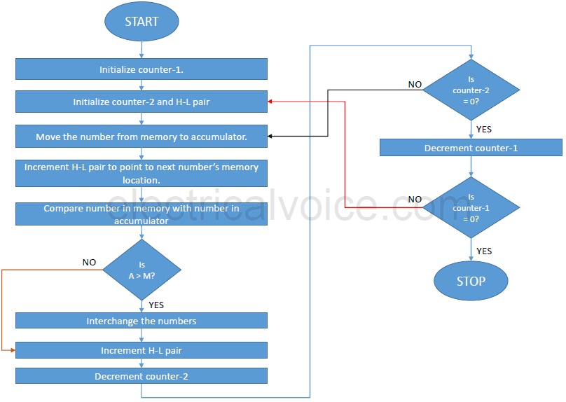

**Algorithm(Ascending order)-**

**–**

1. Load data from offset 500 to register CL (for count).
2. Travel from starting memory location to last and compare two numbers if first number is greater than second number then swap them.
3. First pass fix the position for last number.
4. Decrease the count by 1.
5. Again travel from starting memory location to (last-1, by help of count) and compare two numbers if first number is greater than second number then swap them.
6. Second pass fix the position for last two numbers.
7. Repeate.

**Algorithm(Descending order) –**

1. Load data from offset 500 to register CL (for count).
2. Travel from starting memory location to last and compare two numbers if first number is smaller than second number then swap them.
3. First pass fix the position for last number.
4. Decrease the count by 1.
5. Again travel from starting memory location to (last-1, by help of count) and compare two numbers if first number is smaller than second number then swap them.
6. Second pass fix the position for last two numbers.
7. Repeate.

**Result:**

**Conclusion:-**

____________________________________________________________________________________________________________________________________________________________________________________________________________________________________________________________________________________________________________________

**Industrial Applications:** Various sorting tasks are essential in industrial processes. For example, during the extraction of gold from ore, a device called a shaker table uses gravity, vibration, and flow to separate gold from lighter materials in the ore (sorting by size and weight). Sorting is also a naturally occurring process that results in the concentration of ore or sediment.

**Questions:**

1. What is the advantage of segmentation?

________________________________________________________________________________________________________________________________________________________________________________________________________________________

1. Name the three main addressing modes in 8086.

________________________________________________________________________________________________________________________________________________

1. **Which are the Two Types Of Conditional Jumps.**

**________________________________________________________________________________________________________________________________________________________________________________________________________________________**

1. **Write a code in assembly language to** sort an array of data in ascending order**.**

**________________________________________________________________________________________________________________________________________________________________________________________________________________________________________________________________________________________________**

**________________________________________________________________________**

1. **List some of the features of INTEL8259 (Programmable Interrupt Controller)**

**________________________________________________________________________________________________________________________________________________________________________________________________________________________**

1. **Write a code in assembly language to** sort an array of data in ascending order**.**

**________________________________________________________________________________________________________________________________________________________________________________________________________________________________________________________________________________________________________________________________________________________________________**

7. JB instruction performs the Jump if below (or) Jump if carry (or) Jump if not below/ equal

operations according to the condition, if CF = 1.(True/False).

Ans:______________________________________________________________________

8. INT 3H is called as___________________________________________________________

**9. T**he instruction that unconditionally transfers the control of execution to the specified

address is  
 a) CALL b) JMP c) RET d) IRET

Ans:______________________________________________________________

10. LEA stand for_______________________________________________________________

**Experiment No. 09**

Assembly program based on string instructions (overlapping/non-overlapping block transfer).

**Aim:** Write an assembly language program to transfer data block using string instructions and without using string instructions.

**Objective :** This is for the Overlapping without using string instruction. We already have taken user input of array and its count by calling the “input array” near procedure. Now, first copy all the elements from array1 to array2. Then repeat copying the elements from the position user has provided.

**Software Used:**

Computer system with TASM/MASAM .

### Theory :

### Consider that a block of data of N bytes is present at source location. Now this block of N bytes is to be moved from source location to a destination location.

* + Let the number of bytes N = 10.
  + We will have to initialize this as count in the CX register.
  + We know that source address is in the SI register and destination address is in the DI register.
  + Clear the direction flag.
  + Using the string instruction move the data from source location to the destination location. It is assumed that data is moved within the same segment. Hence the DS and ES are initialized to the same segment value.

Program for non-overlapped and overlapped block transfer of array elements. Takes the array elements from the user and also the number of elements to be overlapped in overlapped transfer. Block transfer here, refers to moving of block of data within the memory to a different location. In non-overlapped transfer we move the data to a completely new location. It is easily accomplished by copying the data using two pointers, one data byte at a time. In overlapped transfer the data block is shifted slightly from the present position, thus, some of the starting elements may overlap with the old position of the last elements in the array. They are therefore copied in reverse order

Algorithm:

Step 1: Create a general purpose 4 parameters macro named “scall” to perform SYS_OUT and SYS_IN, ie output and input operations.

Step 2: Initialize the data section using “section .data” and define all the variables. In this section all variables are like constants during the program. String declaration must be followed by its length calculation in order to use that length during display.

Step 3: Initialize the block starting symbol (bss) using “section .bss”. This section contains all the uninitialized variables.

Step 4: Initialize the code / text section using “section .text” or “section .code”. All the program logic is written in code segment only. It includes the procedures also.

## ****Explanation of various Cases of the program:****

### ****Case 1:****

#### Logic:

This is for the Non overlapping without using string instruction. We already have taken user input of array and its count by calling the “inputarray” near procedure. Now we need to just copy all the array contents from array1 to array2.

#### Code Explanation:

1. Make source index pointer (rsi) point to base address of array1.
2. Make destination index pointer (rdi) point to base address of array2.
3. copy the data present at address of rsi into rax register.
4. copy the contents of rax register into the address pointed by rdi pointer.
5. Increment rsi and rdi by 8 bytes (64 bits, size of each array element).
6. Decrement the count .
7. Jump to step 3 (label “loop6”), until count becomes zero.
8. Jump to label “back”

### ****Case 2:****

#### Logic:

This is for the Overlapping without using string instruction. We already have taken user input of array and its count by calling the “inputarray” near procedure. Now, first copy all the elements from array1 to array2. Then repeat copying the elements from the position user has provided.

#### Code Explanation:

1. Display m5 string and accept 64 bit number in temp.
2. Convert temp into hex format and store it in “posn” and add it to “count1” for the new size of array2.
3. Make source index pointer (rsi) point to base address of array1.
4. Make destination index pointer (rdi) point to base address of array2.
5. copy the data present at address of rsi into rax register.
6. copy the contents of rax register into the address pointed by rdi pointer.
7. Increment rsi and rdi by 8 bytes (64 bits, size of each array element).
8. Decrement the count .
9. Jump to step 5 (label “loop7”), until count becomes zero.
10. Now, as count has become zero, reinitialize it from backup in count2.
11. Make source index pointer (rsi) point to base address of array1.
12. Make destination index pointer (rdi) point to base address of array2.
13. Increment the position of rdi where it points to by 8 bytes(64 bits numbers).
14. Decrement “posn”
15. Jump to step 13 (label loop8) until posn becomes zero.
16. copy the contents of rax register into the address pointed by rdi pointer.
17. Increment rsi and rdi by 8 bytes (64 bits, size of each array element).
18. Decrement the count .
19. Jump to step 16 (label “loop9”), until count becomes zero.

Jump to label “back”.

**Flowchart:**

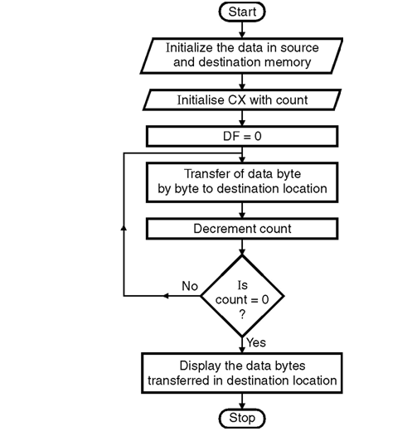

**Algorithm :**

1. Initialize the data in the source memory and destination memory.
2. Initialize SI and DI with source and destination address.
3. Initialize CX register with the count.
4. Initialize the direction flag to zero.
5. Transfer the data block byte by byte to destination.
6. Decrement CX.
7. Check for count in CX, if not zero go tostep 5 else to step 8.
8. Stop.

**Result:**

**Conclusion:** ____________________________________________________________________________________________________________________________________________________________________________________________________________________________________________________________________________________________________________________________________________________

**Industrial Applications**: The 80x86 CPUs can process three types of strings: byte strings , word strings, and double word strings. They can move strings, compare strings, search for a specific value within a string, initialize a string to a fixed value, and do other primitive operations on strings. The 80x86's string instructions are also useful for manipulating arrays, tables, and records. You can easily assign or compare such data structures using the string instructions. Using string instructions may speed up your array manipulation code considerably.

**Questions :**

1. Which register is used as counter register in 8086?

___________________________________________________________________________________________________________________________________________________________________________________________________________________________________________________

1. What is block transfer in 8086.

__________________________________________________________________________________________________________________________________________________________________

3. The instruction that is used to transfer the data from source operand to destination operand is  
a) data copy/transfer instruction b) branch instruction  
c) arithmetic/logical instruction d) string instruction  
Ans:_______________________________________________________________

4. Which of the following is not a data copy/transfer instruction?  
 a) MOV b) PUSH c) DAS d) POP  
 Ans:_______________________________________________________________  
 5. The instructions that involve various string manipulation operations are  
 a) branch instructions b) flag manipulation instructions  
 c) shift and rotate instructions d) string instructions

Ans:_____________________________________________________________

1. List the instruction used in block transfer.

__________________________________________________________________________________________________________________________________________________________________

1. State advantages of string instruction in 8086.

___________________________________________________________________________________________________________________________________________________________________________________________________________________________________________________

1. The instruction that loads effective address formed by destination operand into the specified source register is LEA(True/False)

Ans:____________________________________________________

1. What is overlapped and non overlapped block transfer?

___________________________________________________________________________________________________________________________________________________________________________________________________________________________________________________________________________________________________________________________________

**Experiment N0. 10**

**Aim**:-Write ALP to interface 8255 with 8086

**Objective:** The Intel 8255 is a programmableperipheral interface(PPI) chip wasdeveloped and manufactured by Intel. The students need to understand how the 8255 will be connected with 8086 using different ports. Then students should be able to build program of their own using 8255 & 8086. This is the program which indicates a position of key using LED.

**Problem Statement**: Interface a key to 8255 and indicate its position using a LED i.e

If switch is closed – LED should be ON

If switch is open – LED should be off

**Software Used:**

Computer system with TASM/MASAM

**Theory**:

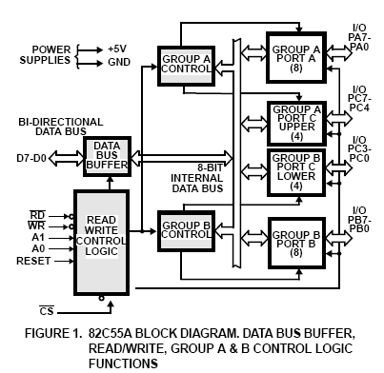

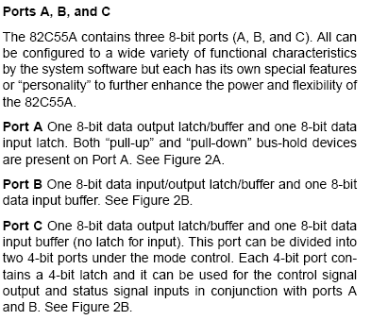

**Algorithm:** Step 1: Initialize 8255 with the control word

Step 2: Initialise port A as input port and port B as output port

Step 3: Assume PA = 80H, PB = 82 H, PC = 84H, CW=86H

Step 4: End

Control Word:

|  |  |  |  |  |  |  |  |
| --- | --- | --- | --- | --- | --- | --- | --- |
| I/O | GA MODE | | PA | PCU | GB MODE | PB | PCL |
| 1 | 0 | 0 | 1 | 0 | 0 | 0 | 0 |

=90 H

Output: Port 86H = 90H (CW)

Port 80 H = input

Port 82 H = output

**Result:** Thus Program and interfacing using 8255/ 8253 was implemented and the output was verified.

**Conclusion:-** Thus 8255 is successfully interfaced with 8086

## Industrial Applications: In this mode, the 8255 may be used to extend the system bus to a slave microprocessor

## or to transfer data bytes to and from a floppy disk controller. Acknowledgement and handshaking signals are

## provided to maintain proper data flow and synchronization between the data transmitter and receiver.

**Questions:**

1. The 8255 designed for______

2. What is function of data bus buffer

_______________________________________________________________________________________________________________________________________________________________________________________________________________________________________________________________

3. What kind of input/output interface dose a PPI implement?

_______________________________________________________________________________________________________________________________________________________________________________________________________________________________________________________________

4. What is function of GroupB control

_______________________________________________________________________________________________________________________________________________________________________________________________________________________________________________________________

5.Define control word in 8255

_______________________________________________________________________________________________________________________________________________________________________________________________________________________________________________________________

6. Draw Control word in 8255

_______________________________________________________________________________________________________________________________________________________________________________________________________________________________________________________________

7. Which pins are general purpose I/O pins during mode-2 operation of the 82C55?

(A) PA0 – PA7 (B) PB0-PB7 (C) PC3-PC7 (D) PC0-PC2

ANS:___________________________________________________________________

8.List the elements of 8255  programmable peripheral interface.

_______________________________________________________________________________________________________________________________________________________________________________________________________________________________________________________________

9.How many I/O lines are available on the 82C55A?

_______________________________________________________________________________________________________________________________________________________________________________________________________________________________________________________________

10. What is the mode and I/O configuration for ports A, B, and C of an 82C55A after its control register is loaded with 82H?

_______________________________________________________________________________________________________________________________________________________________________________________________________________________________________________________________

**References**

1. Intel Microprocessors: Barry B. Brey, 8th Edition, Pearson Education India

2. Microprocessor and Interfacing: Douglas Hall, Tata McGraw Hill.

3. Advanced MS DOS Programming – Ray Duncan BPB

4. Intel 80386 Datasheets

5. IBM PC Assembly language and Programming: Peter Abel, 5th edition, PHI 6. The Pentium Microprocessor, James Antonakons, Pearson Education

6. <https://nptel.ac.in/courses/106108100/pdf/Lecture_Notes/LNm2.pdf>

7. <https://nptel.ac.in/courses/108105102/59>